
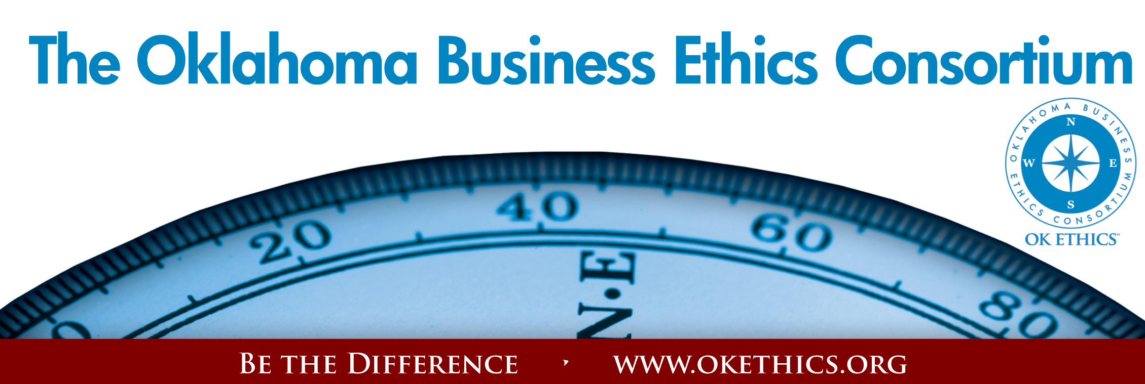
Oklahoma Business Ethics Consortium – August 12, 2009
I. Welcome & Kudos
"Men of integrity, by their very existence, rekindle the belief that as a people we can live above the level of moral squalor. We need that belief; a cynical community is a corrupt community."
-- John W. Gardner
American writer and secretary of Health, Education and Welfare (1912-2002)
Volunteers:
- Greg Byers, Sinclair Broadcasting Group – Registration Chairperson
Mary Kay Huggard, Principal Technologies – Registration Vice Chair
- Jamie Potter, Eide Bailly, LLP – Name badges
- Linda Manaugh, Metro Technology Centers – Handouts
- Bobby Redinger, Cole & Reed - Agendas
- Connie Storey, Maximum Multi Media Creations –PowerPoint
Colin Autin, Oklahoma Accountancy Board – CPE Certificates
- Kellian Schneider, Full Force Marketing & Branding –
Fliers for The Journal Record
- Ambassador Team:
Chade Nash, Gabbard & Company
Sherree Murray, Southern Nazarene University
Kimberly Nation, Accounting Principals
Becky Cavnar, OBU International Graduate School
Special thanks to Member Care Coordinator, Deborah Gavula

II. Early Bird Special - Deadline: August 28

Renew your membership at the Frontier level or above by August 28 and we’ll list your company as a flagship enterprise in a brochure that will be circulated statewide to 4800 subscribers via The Journal Record.
Upgrade or join now and get August & September 2009 programs for the cost of the ten programs offered beginning October 1, 2009.
- Do you know someone who has been laid off?
OK Ethics is offering a free SCOUT membership (value of $75) to any business professional who has been recently impacted by a reduction-in-force. See the website or call 858-2233 for more details. WWW.OKETHICS.ORG

MANY THANKS TO THESE COMPANIES WHO HAVE ALREADY RENEWED FOR FY09-10!!!
Company |  | Level | Chapter
Chesapeake |  | Navigator | Okc
Devon Energy |  | Navigator | Okc
Hobby Lobby |  | Navigator | Okc
Helmerich & Payne, Inc. |  | Horizon | Tulsa
Metro Technology Centers |  | Horizon | Okc
Accel Financial Staffing |  | Leading | Okc
Accounting Principals |  | Leading | Tulsa
BKD, LLP |  | Leading | Okc
BancFirst |  | Leading | Okc
Cherokee Nation Enterprises |  | Leading | Tulsa
Citizen Potawatomi Nation |  | Leading | Okc
McAfee & Taft |  | Leading | Okc
PricewaterhouseCoopers LLP |  | Leading | Tulsa
Coherent Contracts, LLC |  | Trailblazer | Moore/Norman
Leader Communications, Inc. |  | Trailblazer | Okc
Walker Companies |  | Trailblazer | Okc
Character Training Institute |  | Frontier | Okc
East Central University |  | Frontier | Okc
Ideal Homes of Norman, LP |  | Frontier | Okc
Maximum Multi Media Creations |  | Frontier | Okc
Tulsa Metro Chamber |  | Frontier | Tulsa
University of Tulsa |  | Frontier | Tulsa

IV. guiding Principle: Respect Garyl Geist, President -
(Refer to inside front cover of handout for details) OK Ethics Consortium Board of Directors
Chief Executive Officer - Valir Health
- Table Top Discussions - Pick one topic below to discuss with other guests at your table;
survey results will be revealed and discussed by the presenters at beginning of the program
- Your boss announces to the company that there will be no layoffs. Then, less than a minute later, he tells you in strictest confidence that staff must be reduced by 20%. Do you quit? Or, keep your mouth shut in order to keep the paychecks coming so you can feed your family?
- You’ve signed a confidentiality agreement stating that you won’t trash the company. They treated you very badly during the layoff and now you learn that they are rehiring. In fact, your best friend is a candidate for a job under the most treacherous of bosses. Do you warn him/her?
c) You're faced with laying off a mother of five who has had frequent absences vs.
a single bachelor who is highly employable. You know the legal issues, but
your heart tells you something different. What do you do?

“Guideposts for Gut-Wrenching Decisions”
Exploring the Ethical Implications of Layoffs:
A program for healthy survivors
R. Scott Griffin  Director of HR  SandRidge Energy  R. Scott Griffin is the Director of Human Resources for SandRidge Energy, supporting the Employment and Training functions for both the corporate offices and field based personnel. Scott has spent the past 20 years working in Human Resources in the Oklahoma City metro area, the last 13 years in the manufacturing industry. Scott  holds a B.A. in Communication from the University of Oklahoma where he was a Fellows award winner and a member of Mortar Board National Honor Society. | Cheryl French  Practice Leader  Gabbard and Company  Cheryl French has more than 25 years of experience in various leadership and start-up roles domestically and internationally. She has extensive experience with career transition, working with both organizations and individuals to plan and deliver services that impact everyone more positively. She is currently the Practice Leader for Gabbard's Career Transition services. Prior to joining Gabbard, Cheryl worked for a global human resources consulting firm and Core Laboratories, a worldwide oilfield services organization where she held various roles, including human resources, sales management and operations management with full P/L responsibility. She owned her own executive coaching firm specializing in mergers & acquisitions. | Jim Priest  Whitten, Burrage, Priest, Fulmer, Anderson, & Eisel  Jim Priest is a founding member of OK Ethics and one of our most popular speakers. He is a husband, dad, attorney, and ordained minister in the Church of the Nazarene, Jim received his undergraduate degree from Houghton College in Upstate New York and his law degree from Syracuse University. He has practiced law in Oklahoma for nearly thirty years and in the field of employment and civil rights matters. He has consistently been named in the publication The Best Lawyers in America. For more information about Jim's practice see www.employmentarmor.com.  In his personal life Jim's great passion is marriage and family-his own and others'. Jim helped found Marriage Network Oklahoma, an organization that assists churches implement marriage ministries and he appears frequently as a commentator on marriage issues for News 9 in Oklahoma City.
CPE CERTIFICATES
It is the responsibility of participants to demonstrate applicability of each program for demonstration of earned CPE credits, to his/her area of practice. OK Ethics makes no guarantees. Also, attendees must be present to accept CPE certificate at the conclusion of the program.

CPE CERTIFICATES WILL BE ISSUED AT THE BACK OF THE ROOM ON
BEHALF OF NASBA AT THE CONCLUSION OF THIS EVENT
NOTE THAT WE WILL NOT EMAIL THESE

YOU MUST BE REGISTERED ON OUR ATTENDANCE LIST TO
RECEIVE A CERTIFICATE

- Upcoming Events: Bob Byrne, President – OK Ethics Foundation

OKC CHAPTER PRESENTS:

September 9  “The Speed of Trust”  Based on Stephen Covey’s latest book  Presented by  William J. Siems, Boeing  Certified Covey Trainer  Recommended for 1 CPE in Ethics | 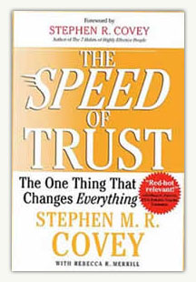

October 14 | November 4
John Richels  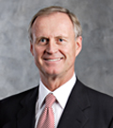 |     Religion’s Impact on Ethical Decision-Making in the Workplace
President, Devon Energy | Father Rick Stansberry;  Our Faiths Columnist,  Andrew Tevington

MOORE-NORMAN CHAPTER PRESENTS:

August 25 | September 16
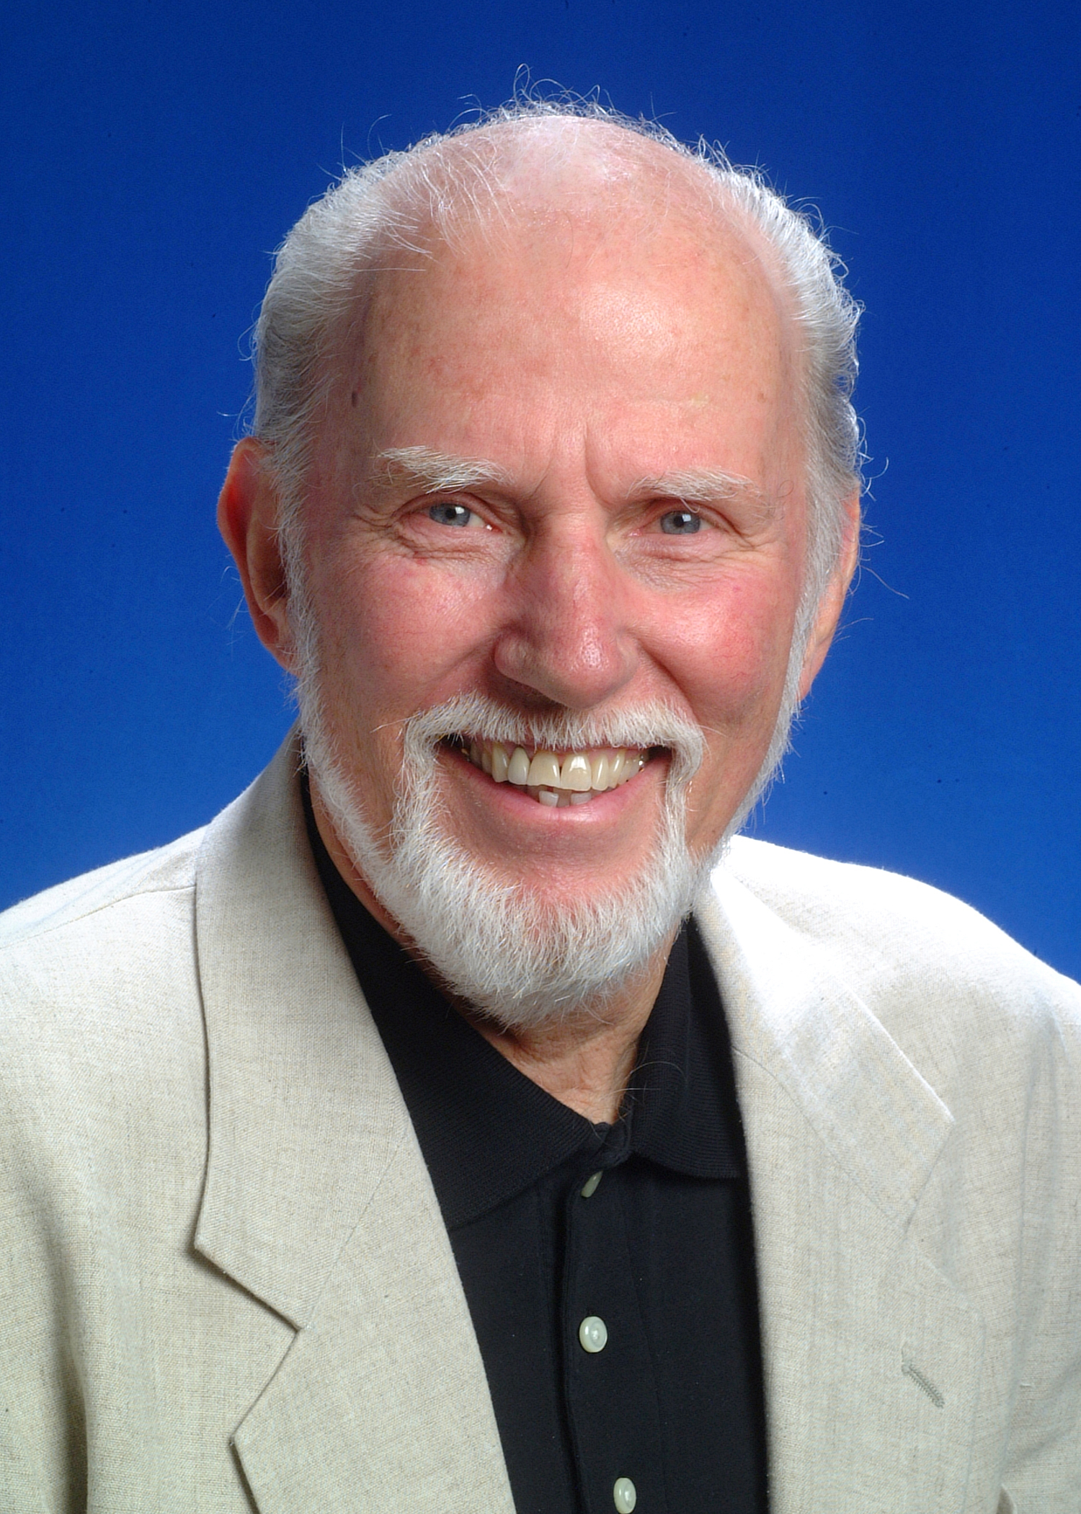  Dr. Tom Boyd  University of Oklahoma | 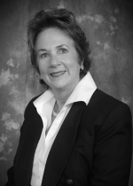  Carolyn  Shockley  Norman  Regional  Health  Care  Systems
“Ethical Maturity”  As individuals, we are constantly striving to evolve. While there are programs delving into emotional intelligence, this program will provide insights on developing  ethical maturity:  Doing the right thing for the right reasons.  Tom W. Boyd is the David Ross Boyd Professor Emeritus of Philosophy at the University of Oklahoma. After teaching philosophy of religion and ethics there for 28 years, he retired from fulltime teaching in 1997. He also retired from the ordained ministry in the Presbyterian Church USA in the summer of 1998.  Tom holds four earned degrees, including a Ph.D. in Religion from Vanderbilt University in 1973. His academic specialization is in philosophical theology, theories of religion, religion and culture, and ethics. His current concentration is on the relation among world religions and the relation between religion and culture. He also studies the impact  of religion on ethics. | “Technology & Ethics  in the Health Care Industry”  REGISTER FOR ALL EVENTS AT  WWW.OKETHICS.ORG

TULSA CHAPTER EVENTS:

August 27  Staying in the Black while Going Green: | September 24  “How to Develop Productive &  Loyal Employees”
The rewards for doing the right thing with our environment  A Panel Discussion   | 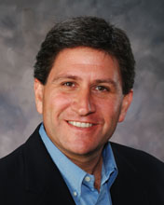  Chet Cadieux  Chief Executive Officer  QuikTrip

- Other upcoming programs of interest:

Character First Institute:
OK Ethics is honored by our friendship with the
Character First! Institute.
They provided wisdom and the basis for our Guiding Principles.
For more information on upcoming Business and Community Leaders' Luncheon, please contact them at 815-0001, or visit www.characterok.org./
Cost is $10 per person. The next topic is
“Responsibility” to be presented on
Tuesday, August 25 or Thursday, August 27

General Disclaimer: Members of the Oklahoma Business Ethics Consortium frequently share information concerning various issues and developments that may have legal implications. The discussions, commentary, and handouts at Consortium meetings or presentations to other organizations are for general informational purposes only. They cover only some aspects of the subject topic, and do not constitute a complete legal analysis of the topic or how it might apply to any particular set of facts. Before taking any action based on information presented during a Consortium event, participants are encouraged to consult a qualified attorney.

The observations and comments of presenters at Consortium meetings and networking are the views and opinions of the presenter and do not constitute the opinion or policies of the Consortium or any of its members. Presenters are respectfully requested to avoid profanity, preaching, politics and self-promotion during their lectures.

